**CATABE**

**Members:** Catienza, Tarquini, Besana

**Overview:**

University students find it difficult to keep track of their academic responsibilities due to its overabundance, personal obligations, or sometimes even financial situations requiring them to work. Due to the lasting effects of COVID-19, many find it difficult to properly keep their tasks in check, with some forgetting to complete their tasks on time, resulting in a severe decrease of academic achievement.

In the current year 2024, students from different programs are finding it difficult to keep up with the increased amount of online tasks given, compared to onsite or face to face learning. As fellow students who have faced these kinds of issues in relation to time management, organization, and task completion, we realized that a solution was needed to ease the minds (and workflow) of students who find difficulty in prioritizing and recognizing deadlines caused by the lack of notifications and access constraints.

**Solving The Problem:**

Students losing track of time and diminishing academic progress, our team came to propose a solution wherein we would create an application that assists students in keeping track of their progress. It will include features such as progress/deadline tracker, designed as a calendar that allows users to see the deadlines of their tasks.

**The Application:**

* **Application Name:** Tsek
* **What it is:** Tsek is a task checklist app developed by CATABE, made for and by students. The application keeps track of your progress with subjects the user has listed, and notifies them of any changes, such as deadlines and additions to their workload.

* **Features:**

Within the application, users may find features such as:

* **Progress/Deadline Tracker:** This feature is used like a calendar to let users check the deadlines of their activities
* **Motivational Quote of the Day:** A window that flashes random motivational quotes to help motivate students
* **Pomodoro Timer:** This features will be used to assist students in timing their work – encouraging users to utilize the Pomodoro Technique

* **Questions about the App:**
* **Who are the potential users?**

The application was created to cater to students (specifically, High School and College) who are doing modular online classes.

* **What tasks do they seek to perform?**

With this application, users can be notified of upcoming task deadlines, and assist in the organization and prioritization of their activities.

* **What functionality should any system provide to these users?**

The main use of this application is to keep track of deadlines and help organize the time users have for these tasks.

* **What constraints will be placed on your eventual design?**   
  -The application will be made for mobile devices only.   
  - Users who are hearing impaired might not be able to hear the notifications, unless the device is on their person at all times.   
  - Users who are visually impaired might find it hard to navigate the application.
* **What criteria should be used to judge if your design is a success or not?**

The criteria for judging if the proposed designs are a success are as follows:   
- The users find the visuals appealing and not hard on the eyes.   
- The features cater to the users’ needs.

- The user finds the design intuitive and easy to understand.

**PART 2**

Tsek is a checklist app that offers users a way to organize their tasks and assist in time management with the use of one application.

**Requirements**  
  
* Location - In order for the app to correctly calculate the time, the app will require the user to turn on Location for determining the current time zone of the user.  
* Internet Connection - This is required for syncing data with your other mobile devices, and for account linking.

**Design Space**

The internet connection required for the sync feature may be hard to realize due to the complexities of cloud storage, and the fact that this application is meant to track the deadlines of tasks.

We considered a feature that could allow users to sync their LMS to Tsek like an extension, however, it seems too unlikely for this to work. Another possible issue we could encounter with

What requirements may be difficult to realize?

What are some tradeoffs that you should or did explore?

Which tasks will be easiest to support? Which are the hardest?

**Design Summary**

These are the alternative designs that we had created before ultimately choosing the final one. We had agreed that some just weren’t very creative or eye-catching, while others were either too messy or tacky to look at, particularly draft 3 of the “CTB” logo, which looks like it’s just been mashed together. For the “Tsek” logo, we chose the first draft because the alternative looked too simple and doesn’t properly convey what the app is supposed to be.

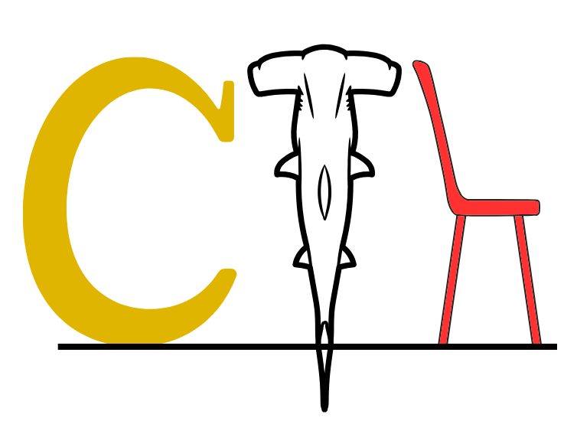

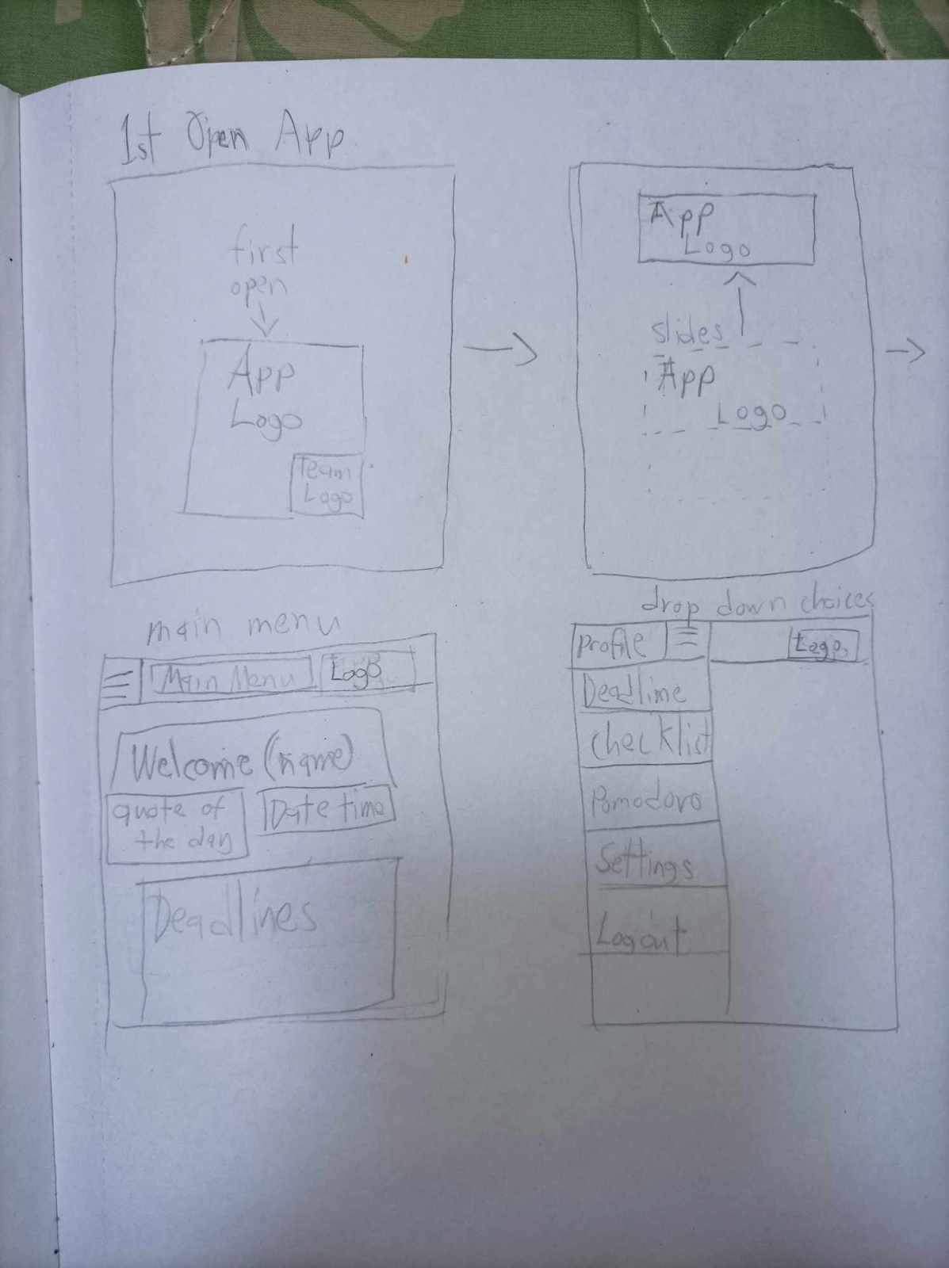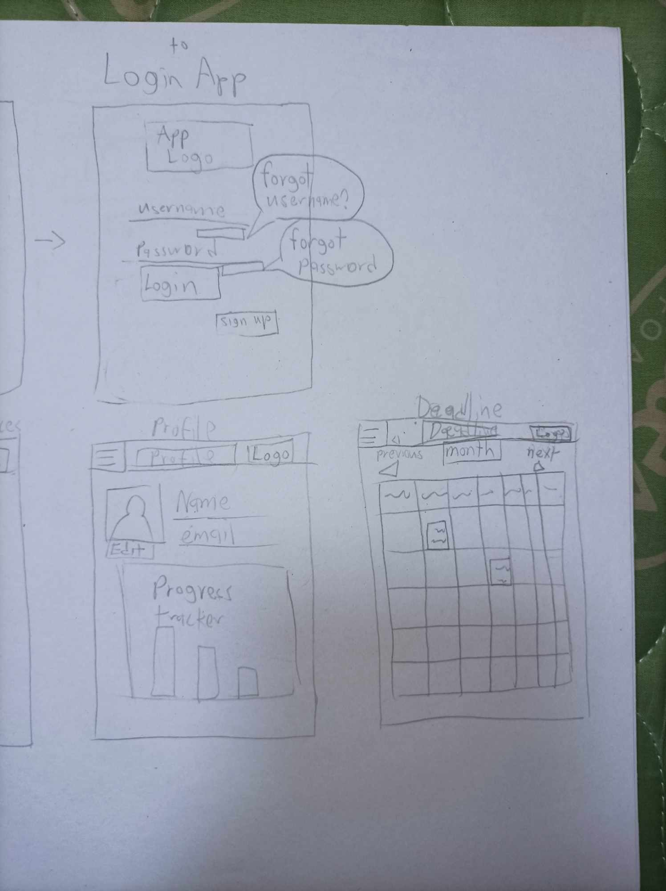

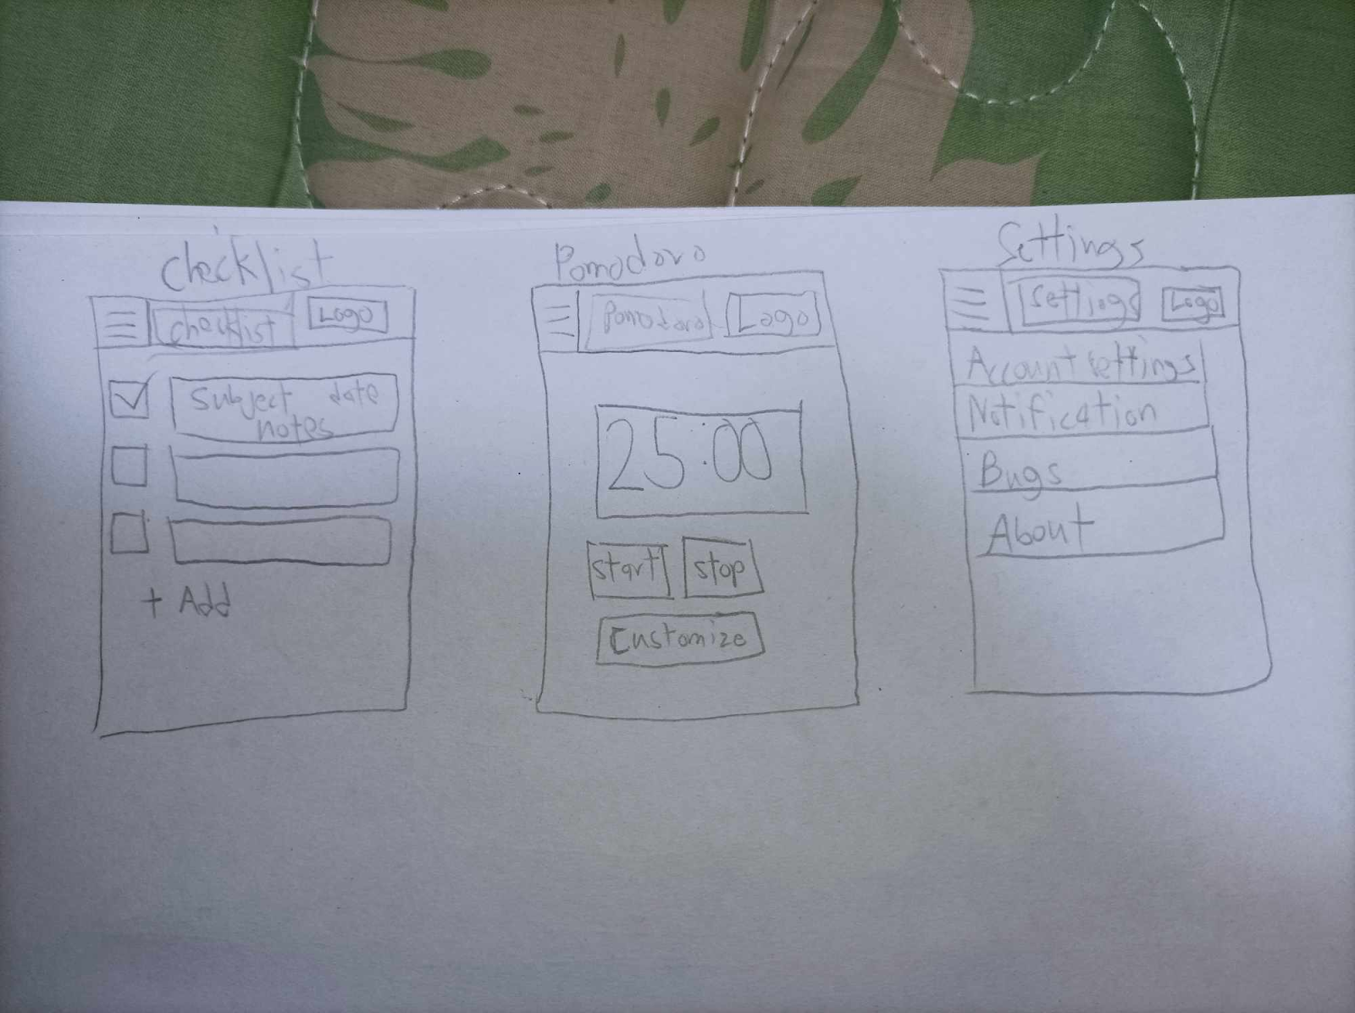  
These prototypes are very similar to the final outcome, and are only different with some smaller details and such.

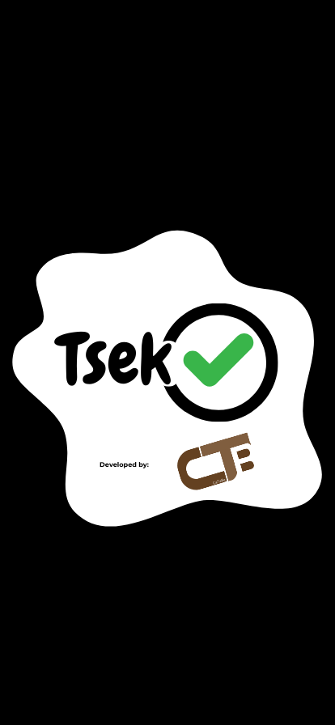

**This is the opening screen when the application is opened for the first instance, and contains the logo of the application and the developer’s logo. It serves as a quick way to launch the application to the next part.**

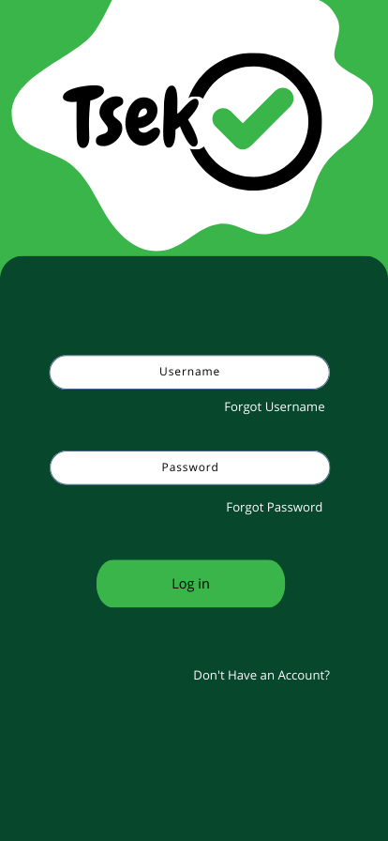

**If the user of the app has not logged in to their account or does not have one yet, this will be shown as the initial process of using the application. There are options that will aid the user if they have forgotten their username or password and have a sign-up button to make a new one.**

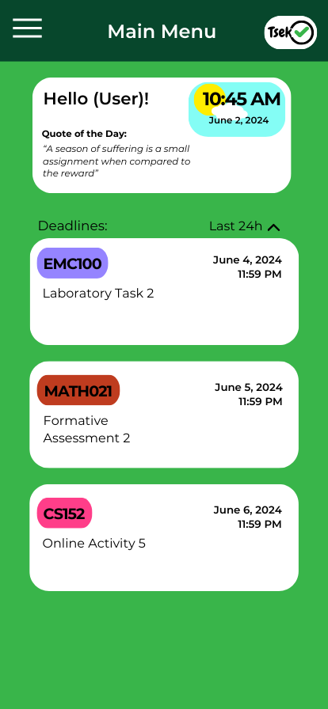

**This is the Main Menu screen, this is where the users will see after the initial process such as the login screen. This is also the screen that is used for those who are already logged in prior. The main menu greets the user with their name, a clock that shows the time and date that has a background that corresponds to the time, and a quote that changes every day to keep the user motivated. The logo and the name of the area is shown at the top area, alongside the collapsible button. The main menu also shows a simple view of the deadlines, which can be sorted by time.**

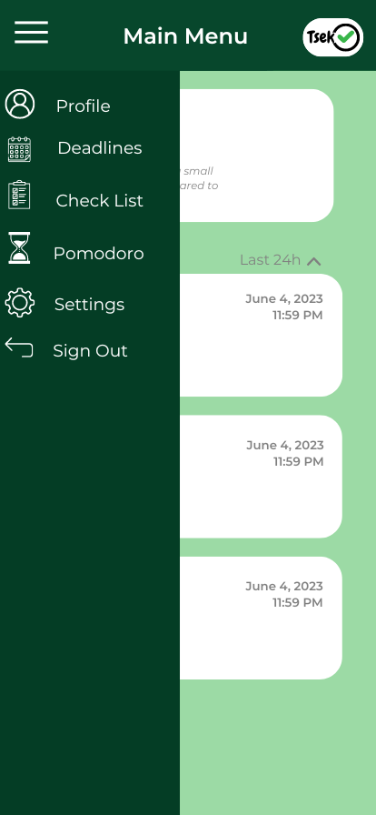

**The collapsible button shows the other parts of the application, which include the profile, deadlines, checklist, Pomodoro, settings, and a sign-out button.**

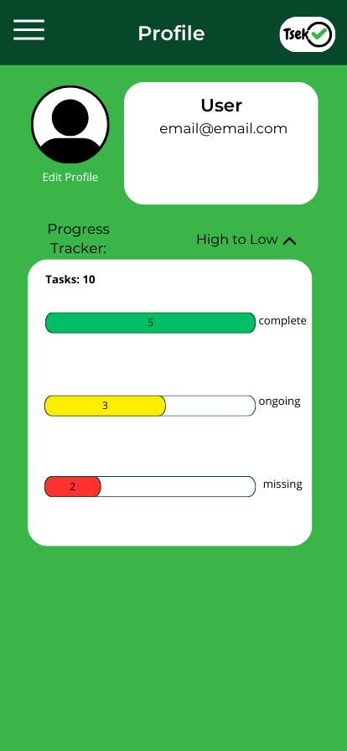

**The Profile shows the information that is crucial to the progress of the user. It has the picture, name, and active email that is being used. It can also be edited with the edit profile underneath the profile picture. The progress tracker shows the tasks amount of tasks added to the application and shows which ones are completed, ongoing, and are missed.**

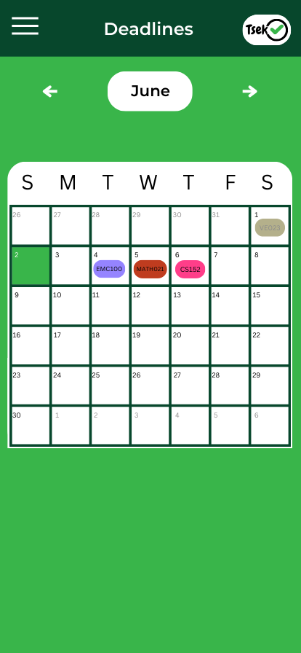

**The Deadlines shows a calendar with the current month but it also can check the previous and the upcoming months. The green tile shows the current date which helps indicate how near or how far a task is if a task that was already done previously or in advance will be semi-transparent to help the user identify which was done or not.**

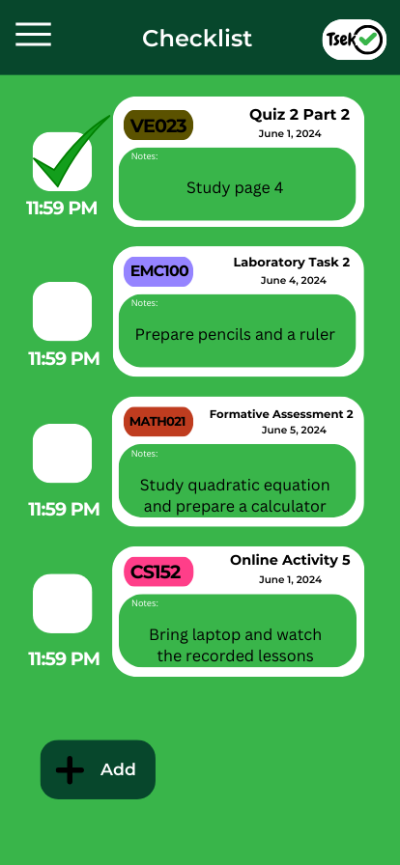

**The Checklist shows the task that have been added and marks them if they are completed by the user, information such as the name of the subject, name of the task, date, and notes that the user can add as a self-reminder with that task.**

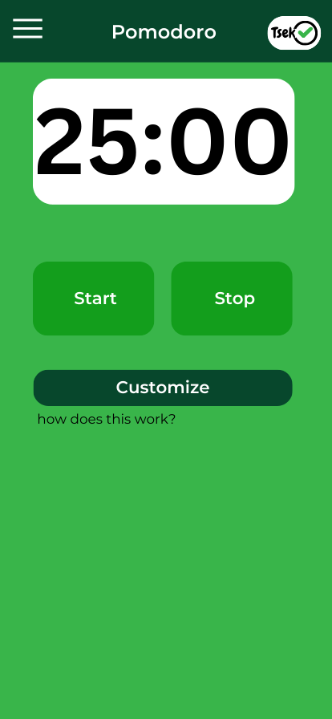

**The Pomodoro timer helps the user to manage their time when doing their task. The default time is 25 minutes to do the task and 5 minutes break. A start and stop button is used to initiate and halt the operation of the Pomodoro timer. A customize button is also added to let the user choose their preferred time.**

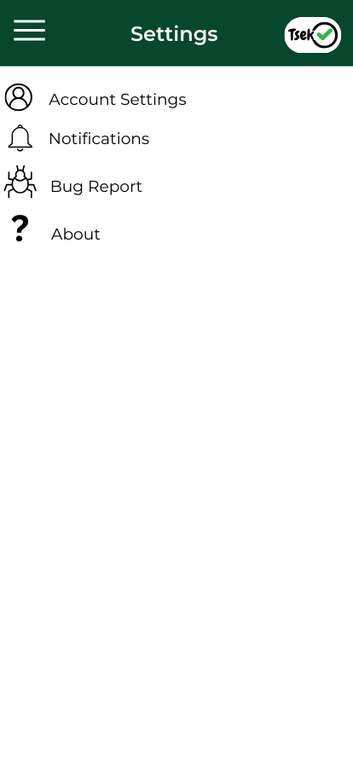

**The settings button shows the basic redirections to things like the account settings for setting up the account like the password, to even deleting the account itself, notifications for the reminders of the application to the user, bug reports for the user to inquire about an issue with the application and the about for the application version, developer information and so on.**

**PART3.1:**

**Project Description:**

Tsek is a mobile app designed to help students manage their academic responsibilities. Ideal for high school and college students, Tsek features a progress/deadline tracker, motivational quotes, and a Pomodoro timer. These tools help users stay organized, prioritize tasks, and maintain focus. With a user-friendly interface and essential notifications, Tsek aims to enhance productivity and improve academic performance.

**Requirements Summary**

|  |  |  |
| --- | --- | --- |
| **MINIMUM REQUIREMENTS** | Processor Cores | Single Core |
| OS | Android 4.4 (KitKat) |
| RAM | 2 GB |
| **RECOMMENDED REQUIREMENTS** | Processor Cores | Quad Core |
| OS | Android 8.0(Oreo) |
| RAM | 4 GB |
| **OTHER REQUIREMENTS** | Permissions | Notifications and Storage |

*Table 1. System Requirements*

To accommodate all users, the minimum requirement is 2 GB of RAM which is sufficient to be used in any device.

**Prototype Description**

The Tsek app prototype was made using Microsoft PowerPoint. This prototype features interactable buttons, navigational windows, and additional screens for editing the Checklist and Pomodoro Timer tasks.  
  
[CATABE_APPLICATION.ppsx](https://malayancollegesmindanaoo365-my.sharepoint.com/:p:/g/personal/mecatienza_mcm_edu_ph/EUMO4IZDI8RLkW7XE4SvqUMBYlACyLVDyfGhs4DxTiWNUw?e=sGamwt)

**User Scenario**

Billy and Nicole are college students and have been dealing with tasks and assessments given to them by their professors. They needed help keeping track of their tasks and managing them. Billy found an application named “Tsek” which had features that could help with their situation.

**Prototype Design**

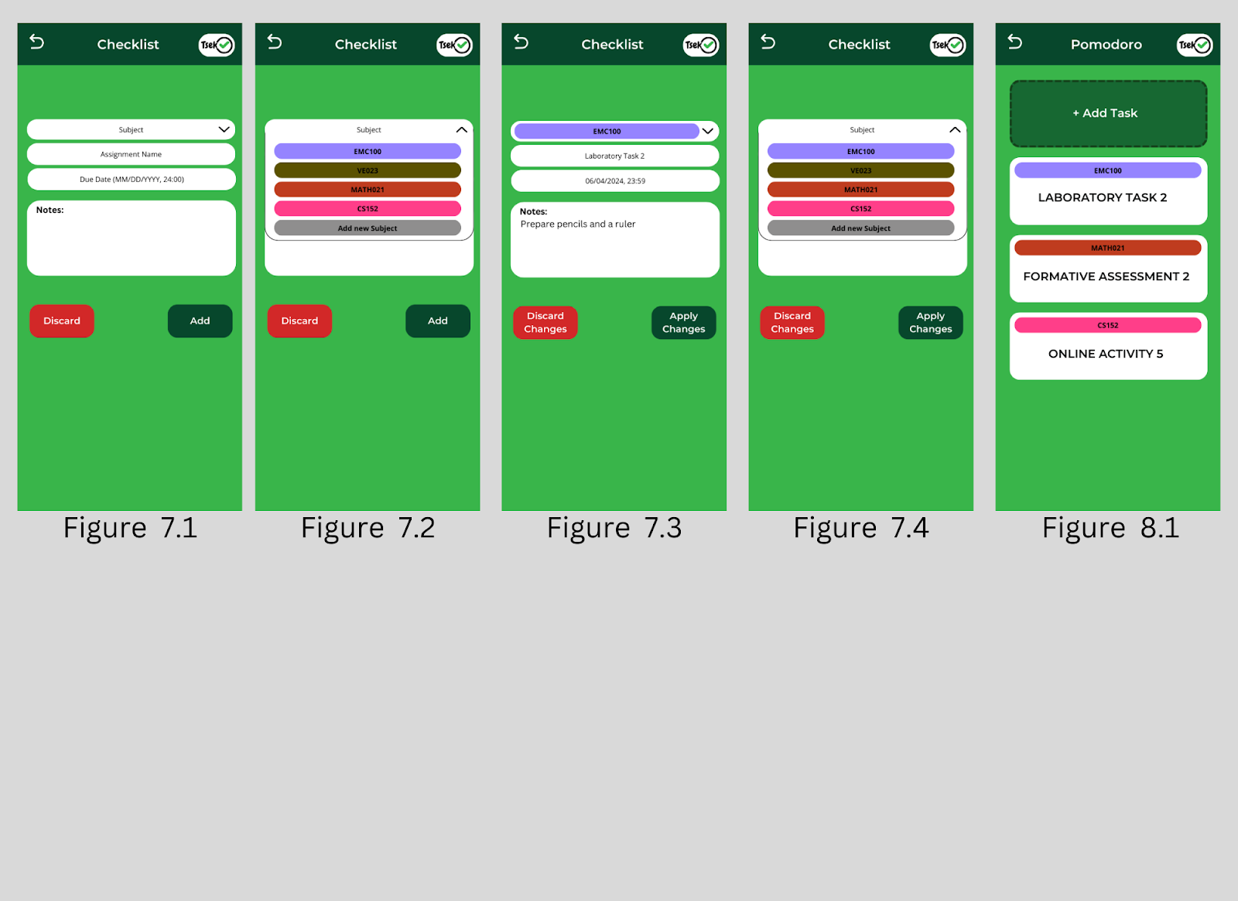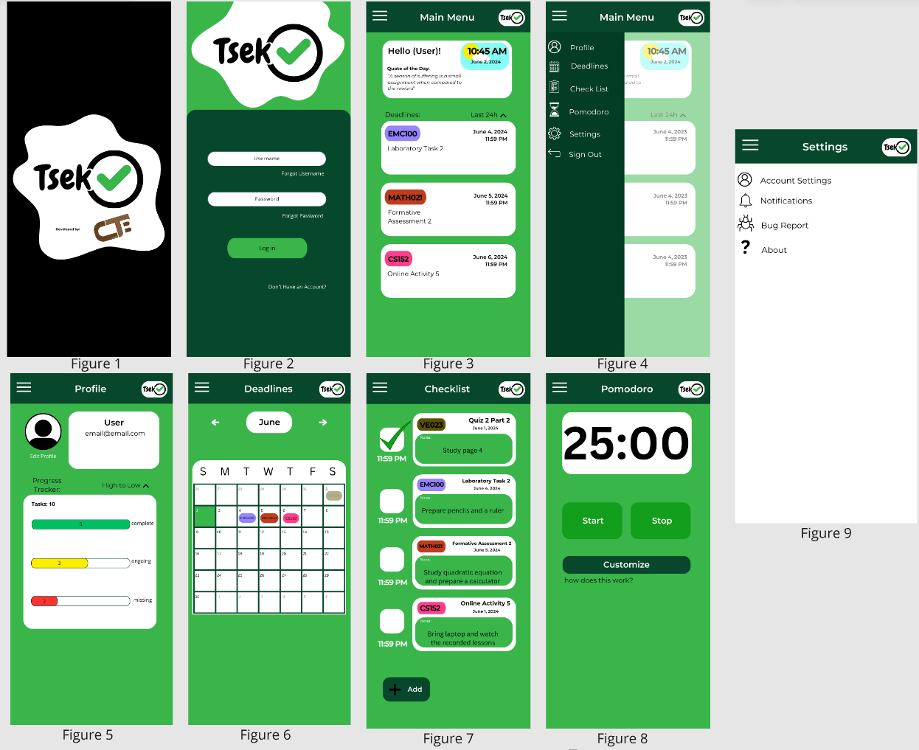

Upon launching the application for the first time, the opening screen shows the application and developer logos, serving as a quick entry point. If users haven't logged in or don't have an account, they see an initial setup screen with options for recovering usernames or passwords and a signup button. After logging in, the Main Menu screen welcomes users by name, featuring a dynamic clock, a daily motivational quote, and a simple view of upcoming deadlines.

A collapsible burger menu (A.K.A. the Navigation Bar) reveals additional sections: Profile, Deadlines, Checklist, Pomodoro, Settings, and sign-out. The Profile section displays essential information, allows profile editing, and tracks task progress. The Deadlines section presents a calendar with navigation to past and future months, highlighting completed tasks and the current date. The Checklist section lists tasks with details such as subject name, task name, date, and user-added notes. The pages in Figure 7.1-7.4 display the editing section of the Checklist function. The Pomodoro timer helps manage task time with default work and break periods, featuring start, stop, and a customize button for adding tasks to prioritize. Figure 8.1 shows the page for adding tasks in the Pomodoro function. The Settings section provides access to account management, notification preferences, bug reporting, and application version details.

**Rationale:**

The primary aim of Tsek's development is to offer students a straightforward method to manage their academic tasks. The app focuses on usability and simplicity, ensuring that users can easily track deadlines and organize their responsibilities. Upon launching the app, users see a welcoming screen, and if needed, an initial setup process for new accounts. The Main Menu provides a personalized greeting, a dynamic clock, motivational quotes, and a quick view of deadlines. With sections like Profile, Deadlines, Checklist, Pomodoro, and Settings easily accessible, Tsek streamlines task management. This design enhances productivity and academic performance with minimal effort, making it an effective tool for students.

**Changes to requirements**

No specific changes were made to the system requirements; however, two major changes were made to the usability criteria for the prototype. These changes were necessitated by the lack of resources. Initially, we aimed to implement internet connectivity and account syncing features within the application. However, due to time constraints, we implemented a local account management system that does not require internet connectivity instead. This adjustment ensures users can still manage their tasks effectively without relying on an internet connection.

**Initial Evaluation Plan:**

We conducted an evaluation for the Tsek prototype with college students as participants. The evaluation was carried out online using platforms like Microsoft Forms for ease of access. Using a two-part evaluation first has a Likert scale with general evaluation and the second focuses on interactive areas. With that, the objective was to identify the application's general functionality and interactivity to the user.

**Project Description:**

Tsek is a mobile app designed to help students manage their academic responsibilities. Ideal for college students, Tsek features a progress/deadline tracker, motivational quotes, and a Pomodoro timer. These tools help users stay organized, prioritize tasks, and maintain focus. With a user-friendly interface and essential notifications, Tsek aims to enhance productivity and improve academic performance.

**Requirements Summary**

|  |  |  |
| --- | --- | --- |
| **MINIMUM REQUIREMENTS** | Processor Cores | Single Core |
| OS | Android 4.4 (KitKat) |
| RAM | 2 GB |
| **RECOMMENDED REQUIREMENTS** | Processor Cores | Quad Core |
| OS | Android 8.0(Oreo) |
| RAM | 4 GB |
| **OTHER REQUIREMENTS** | Permissions | Notifications and Storage |

*Table 1. System Requirements*

To accommodate all users, the minimum requirement is 2 GB of RAM which is sufficient to be used in any device.

**Overview**

We conducted a survey for the Tsek prototype and asked college students to be our participants. It was hosted online on Microsoft Forms. Using a two-part evaluation first has a Likert scale with general evaluation and the second focuses on interactive areas. With that, the objective was to identify the application's general functionality and interactivity to the user.

|  |  |
| --- | --- |
| **Technique** | **Description** |
| Likert scale Evaluation | Likert Scale Evaluation will assess the UX design of the Tsek prototype against industry-standard usability principles. This method provides a structured approach to gauge user perceptions and satisfaction with the app's design, particularly useful for evaluating its effectiveness and user-friendliness under constrained time or resource conditions. |
| Participant Survey and Feedback | After interacting with the Tsek prototype, participants will be given a survey. The survey will include quantitative questions rated on a 5-point Likert Scale and qualitative questions for open-ended feedback. This method ensures unbiased evaluation results, allowing participants to provide structured ratings and detailed insights into their experience with the app's features and usability. |

*Table 2. Evaluation Plan*

The objectives for this prototype are divided into 3 parts: Usability Specifications, Likert scale Evaluation, Participant Survey and Feedback. The user will be asked to access the App Testing Form where they can try the application, thus here are some survey questions prepared, and will be using a 5-point Likert scale to evaluate the prototype:

**SECTION 1:**

**This section will discuss the general user evaluation of the prototype.**

* How would you rate your experience with the Tsek prototype?
* How would you rate the Ul design of the Tsek prototype?
* How easy was it to follow the provided tasks/navigate the Tsek prototype?

**SECTION 2:**

**This section will discuss the overall design, functions, and appearance of each page:**

- Login Page

-Main Menu Page

-Navigation Bar

-Profile Page

-Deadline Page

-Checklist Page

-Pomodoro Page

-Settings Page

**Microsoft Forms Image:**

A survey administration software was used to gather the responses of the users.

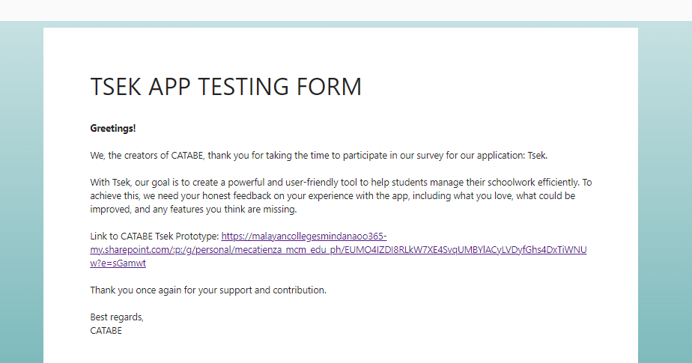

**Tsek App Prototype Message:**

Within the Tsek App Prototype, the testers are greeted with a message that gives them short instructions on how to proceed with the prototype.

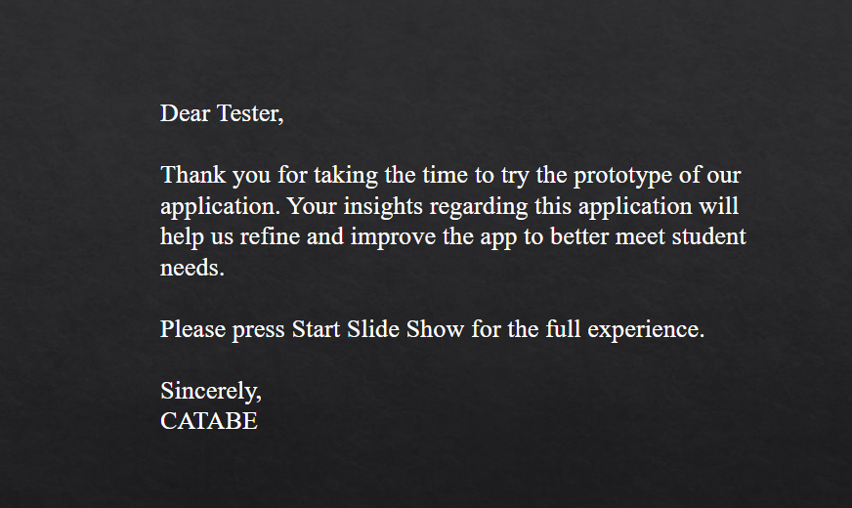

**Data Presentation**

**Data Analysis**

|  |  |  |  |
| --- | --- | --- | --- |
| **SECTION 1** | | | |
| Question | Mean | Interpretation | Classification |
| On a scale from 1-5 how would you rate your experience with the Tsek prototype? | 4.40 | Highly Acceptable | Successful |
| On a scale from 1-5 how would you rate the UI design of the Tsek prototype? | 3.80 | Acceptable | Neutral |
| How easy was it to follow the provided tasks/navigate the Tsek prototype? | 4.60 | Highly Acceptable | Successful |
| **SECTION 2** | | | |
| Login Page | 4.00 | Moderately Acceptable | Successful |
| Main Menu Page | 4.00 | Moderately Acceptable | Successful |
| Navigation Bar | 4.20 | Moderately Acceptable | Successful |
| Profile Page | 3.60 | Acceptable | Neutral |
| Deadline Page | 4.60 | Highly Acceptable | Successful |
| Checklist Page | 4.60 | Highly Acceptable | Successful |
| Pomodoro Page | 4.60 | Highly Acceptable | Successful |
| Settings Page | 3.40 | Acceptable | Neutral |

*Table 3. Data Results*

Table 3 shows the results of all the data from the 5-point Likert-scale questions of Section 1 and 2. This data shows that the prototype was mostly smooth in terms of flow and functionality.

**Feedback:**

While the majority of the data shows positive conclusions regarding the app, it still falls short on a few aspects such as the UI of certain pages. Specifically, the Profile and Settings pages. Some users found the UI of both pages too simple or bland, which led to a low score in the survey.

**Design Implications:**

* Does your prototype need to be altered in order to address the results of the analysis, or was it completely successful?
* While the survey shows that the application is successful, there are other parts of the app that still need improvement, such as better UI design.
* What improvements could be made to the design to address any shortcomings?
* In order to address these issues, the best solution would be to overhaul the UI of the Settings and Profile to better clarify its purpose and give better visuals. Another way is to make the visuals more consistent with each other.
* Did you discover any major flaws that would suggest a completely different type of design?
* There were no major flaws present in the design of the app.

**Critique and Summary**

* What were the advantages and disadvantages of your evaluation?
* With the evaluation, we found flaws that we otherwise couldn’t have considered, and we wouldn’t have made these changes based on the users’ experience testing the application. As for disadvantages, due to time constrictions, we were not able to do a proper evaluation with Interviews and had to scrap this idea.
* What would you have done differently knowing what you know now (both designwise and evaluation-wise)? Given more resources, what could you have done that would have produced significantly more insightful evaluation results (again, whether this is an improved prototype or a different evaluation path).
* Knowing what we know now, there are a lot of changes we could apply to the app to make it a lot more effective and visually pleasing. For instance, adding a cloud sync feature (which we had scrapped) and connection to the internet would be very helpful for using multiple devices. Making a PC port would also be useful, and using a better color palette for the app’s UI. If we could dedicate a lot more time and resources for the app, we would apply these criticisms given by the users and improve the app’s functionality.

**Summary of the Project**

The majority of the users shared a common critique regarding the appearance of the profile page and the settings page, for they were too simple or mediocre from what the survey has gathered. Many remarked it lacked an aesthetic appeal. Few also pointed out that the lack of online connectivity and account syncing can cause proper arrangement of completed, outdated tasks to ones from newer unopened or even unfinished tasks.

The survey in conclusion showed a positive result in response from the users, with their experience, rating on the UI design, and how simple and smooth the navigation of the application.